Tetyana FILIMONOVA
candidate of sciences in physics and mathematics, associate professor, (orcid.org/XXX)
State university of trade and economics, Kyiv, Ukraine
Maksym KOSENKO
student (orcid.org/XXX)
State university of trade and economics, Kyiv, Ukraine

OBJECTS DETECTION IN IMAGES USING DEEP NEURAL NETWORKS

The problem of object detection in computer vision requires the simultaneous solution of two tasks: localization and classification. Object detection allows you to identify and determine the position of all objects of different classes within a single scene. Comparing different architectures and object detection methods is a key practice in determining the performance of models. Fig. 1 presents the general architecture of the YOLOv8 model [1].
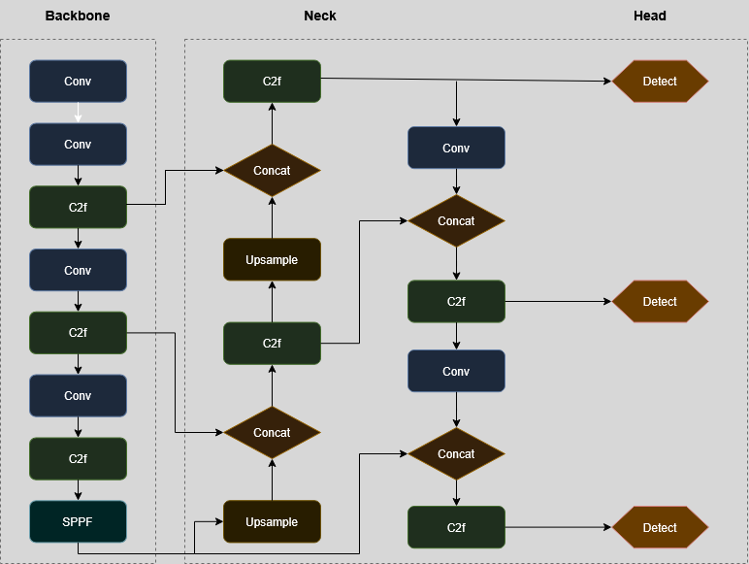
Fig. 1. Generalized architecture of the YOLOv8 model [1].
The model's effectiveness is determined by a whole list of interrelated factors. Typically, the main criteria for evaluating detectors are the accuracy of their predictions and the speed of image processing [2]. The work focuses on those indicators that have already become a generally accepted standard in object detection tasks and are especially recommended for evaluating models such as YOLO [3 4]. Precision — this metric quantitatively shows what proportion of all objects that the model marked as positive actually are. The formula for Precision [3]:
$Precision = \frac{TP}{TP + FP}$ (1)
where TP is the number of times the model correctly found and named the object and the frame matched well (IoU above our threshold), FP is when the model either got the object wrong (called the background an object), or correctly identified the object but the frame was inaccurate (IoU below the threshold), or misclassified altogether [5].
The analysis of the training process itself was carried out based on data from the results.csv file (which is automatically generated by the Ultralytics framework). This allowed us to track the dynamics of the model's key indicators. Fig. 2 shows graphs of the loss functions for the training and validation sets.
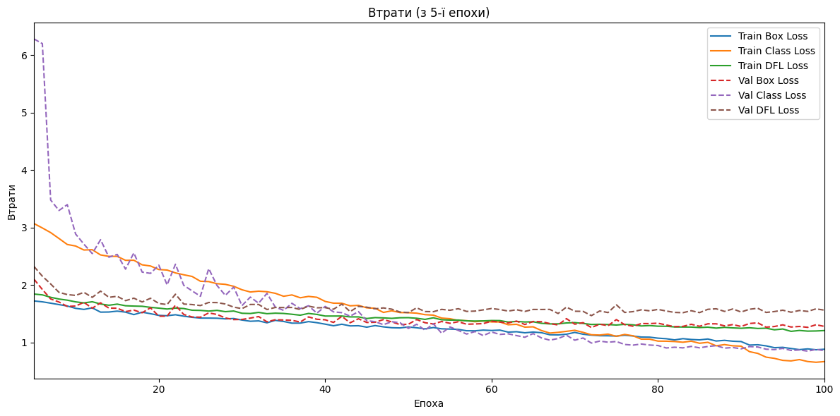
Fig. 2. Loss functions dynamics during training and validation of the YOLOv8s model.
After training, the model was evaluated on a test set consisting of 150 samples (112 for class 0 and 38 for class 1). Classification report in Table 1.
Table 1. Model classification report.
Class | Precision | Recall | F1-Score | Support
0 | 1.00 | 1.00 | 1.00 | 112
1 | 1.00 | 1.00 | 1.00 | 38
Accuracy |  |  | 1.00 | 150
Macro Avg | 1.00 | 1.00 | 1.00 | 150
Weighted Avg | 1.00 | 1.00 | 1.00 | 150
The limitations identified, including lower accuracy for some classes and sensitivity to specific visual patterns, point to areas for further improvement. This could include expanding the dataset [6], especially for problematic classes, applying more sophisticated augmentation techniques, fine-tuning hyperparameters, or experimenting with larger YOLOv8 models.

References
1. Ge, Z., Liu, S., Wang F., Li Z., & Sun J. (2021). YOLOX: exceeding YOLO series in 2021 (arXiv:2107.08430). arXiv. https://doi.org/10.48550/arXiv.2107.08430
2. Lin, T.Y., Goyal, P., Girshick, R., He K., & Dollár, P. (2021). Focal loss for dense object detection. IEEE Trans. on Pattern Analysis and Machine Intelligence, 42(2), 318–327. https://doi.org/10.1109/TPAMI.2018.2858826
3. Trigka, M., & Dritsas, E. (2025) A comprehensive survey of machine learning techniques and models for object detection. Sensors, 25(1). 214. https://doi.org/10.3390/s25010214
4. LearnOpenCV. (2025). CNN: Mean average precision (mAP) in object detection. Retrieved from https://learnopencv.com/mean-average-precision-map-object-detection-model-evaluation-metric/
5. Padilla, R., Passos, W.L., Dias, T.L.B., Netto, S.L., & da Silva, E.A.B. (2021). A Comparative Analysis of Object Detection Metrics with a Companion Open-Source Toolkit. Electronics, 10(3), 279. https://doi.org/10.3390/electronics10030279
6. Chollet, F. (2021). Deep Learning with Python (2nd ed.). Manning, New York

